BLC to Michelago – 9 September 2018

The trip will start at Spotlight carpark, Queanbeyan at 10.00 am for a 10.15 am start.
We will travel from Queanbeyan to Michelago via Jerangle- Captains Flat Road and Tinderry Road. This is an easy trip on blacktop and formed dirt roads. Tinderry Road has some wonderful views (see photo below) and is an interesting road to navigate.
Lunch will be at the Michelago General Store and Tea Rooms and while not a large range the food is very nicely cooked. (meals will be pre-ordered for this trip).
There is the option to continue on after lunch to have a look at the Bredbo Christmas Barn.

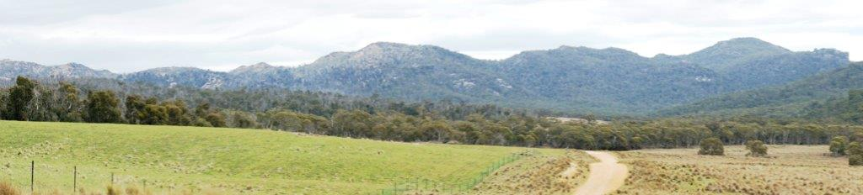

BLC to Gunning – 13 October 2018

Just a short 46min trip to Gunning for an excellent breakfast at the Old Hume Café.
Meet at Gundaroo Park (sports oval/showground) at 8.30am for an 8.40am start.
We will be travelling the back roads to Gunning, Marked Tree Rd and Collector Rd, so there is a fair amount of dirt road but some lovely scenery.
Looking for something a bit different to see? The Australian Stock Horse Society Southern Highlands Branch Show is on 13-14 October. An action packed equine programme that demonstrates the versatility and athleticism of the Australian Stock Horse as well as the skills and horsemanship of the rider. Gunning Showgrounds, Cnr Copeland & Nelango Streets, Gunning.

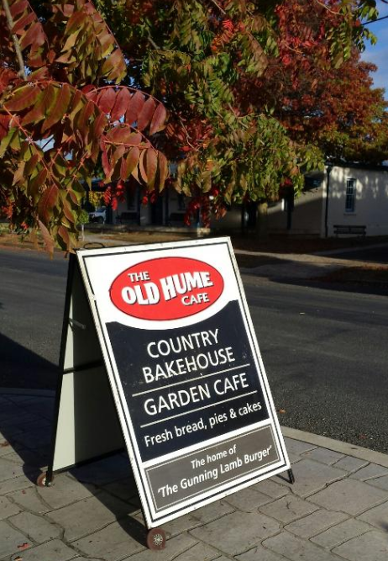
LRC Christmas Event 2018 - Note date change
The Club’s 2018 Christmas event will be held on 24 November. Location to be advised.
Usual activities will include dinner on Friday night for those arriving early, and a morning drive and lunch on Saturday ahead of the Saturday night celebrations. Also activities for the kids, as well as prizes for the best decorated table, best Christmas outfit, and best decorated camp site.
Come and celebrate another great year with the Land Rover Club of ACT.

